###### Sitecore – Add missing icons for specific media types – Vincent – Technologist

**SITECORE HACKATHON 2022**



**Topic**

**Best Addition to the Sitecore MVP site**

|  |  |
| --- | --- |
| **Team Name** | : SitecoreShade |
| **Team Members** | : Arul Pushpam Murugan, Chirag Goel |
| **Date** | : 05-March-2022 to 06-March-2022 |
|  |  |

**Usage Instructions for Enhancments**

1. To add LinkedIn and Twitter for an MVP. You have to edit the field values in the path /sitecore/content/MvpSite/MVP Repository/People/{MVPName}.

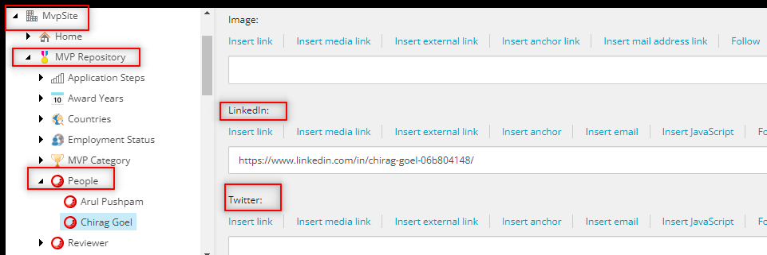

1. To add the Reviewers you have to add the Reviewer by going to path /sitecore/content/MvpSite/MVP Repository/Reviewer and right click on the item and select Person.

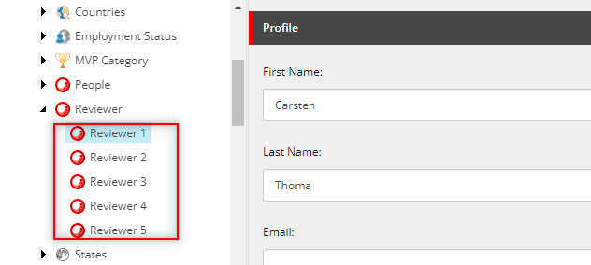

**Resultant output**

Here are some of the sample screenshots of the enhancement we have performed in Sitecore MVP website:

